Blood bridge: Optimizing Lifesaving
Resources

Prepared For
Smart-Internz
Cloud Practitioner
Guided project

By
Rajvardhan Shashikant Patil
D Y Patil Agriculture and Technical University Talsande



Final Project Report
Table of Contents
Introduction 3
Project Initialization and Planning Phase 4
System Architecture Document 5
System Architecture Diagram 6
Project Proposal (Proposed Solution): 6
Initial Project Planning: 7
AWS Services Utilized 9
Application Deployment Steps 10
Advantages &Disadvantages: 13
Conclusion: 15
Future Scope 16

Abstract
BloodBridge is an AWS-powered solution designed to optimize the end-to-end lifecycle of blood management from donation to transfusion. It introduces real-time tracking, automated request processing, and robust data handling to improve emergency responsiveness and reduce wastage.

Introduction

In the ever-evolving landscape of healthcare, timely and efficient access to lifesaving resources remains a critical priority. Among these, the availability and distribution of blood products stand at the forefront of emergency and routine medical care. However, traditional blood bank systems continue to face significant operational challenges—including outdated inventory methods, disconnected stakeholders, and delayed response times—leading to avoidable fatalities and resource wastage.
BloodBridge aims to revolutionize this ecosystem by delivering an intelligent, cloud-native blood management platform that harnesses the power of AWS services. Designed with scalability, security, and real-time responsiveness in mind, BloodBridge serves as a digital bridge between donors, hospitals, blood banks, and administrators. Through its innovative architecture and technology-driven workflows, the platform enables automated donor tracking, demand forecasting, and seamless request fulfillment—all while ensuring data security and compliance with healthcare regulations.
- Purpose
The primary objective of BloodBridge is to create a centralized, intelligent, and accessible system that manages the lifecycle of blood collection, storage, and distribution. By integrating real-time data processing with scalable cloud services, the system ensures that the right type and quantity of blood reaches the right place at the right time, thereby improving patient outcomes and operational efficiency.
- Scope
This project encompasses:
- A web-based interface for donor registration, hospital requests, and inventory dashboards.
- Backend services for handling request workflows, role-based access, and data processing.
- Integration with AWS cloud infrastructure for compute, storage, security, and analytics.
- A scalable and modular architecture to support future enhancements like AI-based demand prediction and mobile app integration.
4. Significance
BloodBridge addresses the following pressing issues:
- Emergency blood shortages due to poor visibility and coordination.
- Manual data management leading to delays and inaccuracies.
- Lack of a real-time, secure, and unified system connecting all stakeholders.
- Limited technological adoption in small and medium blood centers.
By introducing this platform, we aim to empower healthcare providers with tools that ensure faster response times, reduce operational overhead, and enhance donor and recipient experiences. The solution contributes toward achieving the broader goal of saving lives through timely access to vital blood resources.

Project Initialization and Planning Phase

Problem Statements

PS  No. | I am  (Customer) | I’m trying to | But | Because | Which makes me  feel
PS-  1 | A hospital administrator  (Sarah) | Request rare blood urgently during emergency | It takes too long to find matching donors | Manual  coordination is slow | Helpless and anxious in saving patient lives
PS-  2 | A regular donor (John) | Manage and schedule my blood donations | I’m not sure when I’m  eligible or where to go | I don't get updates on nearby donation drives | Disconnected from helping regularly
PS-  3 | A blood bank manager (Lisa) | Update and broadcast realtime inventory | My current system doesn’t sync across hospitals | No centralized, real-time update tool | Frustrated and worried about mismanagement

System Architecture Document
Components:
- Application Layer:
  - Hosted on Amazon EC2 instances • RESTful APIs using Node.js/Python
- Data Layer:
  - Amazon RDS: Relational data (users, hospitals) • Amazon DynamoDB: Real-time blood stock data
- Storage:
  - Amazon S3: Reports, documents, images
- Authentication:
  - Amazon Cognito for secure login & session management
- Monitoring:
  - AWS CloudWatch for system logs
  - AWS CloudTrail for API access tracking
Architecture Flow:
User > API Gateway > Lambda/EC2 > RDS/DynamoDB > S3

System Architecture Diagram

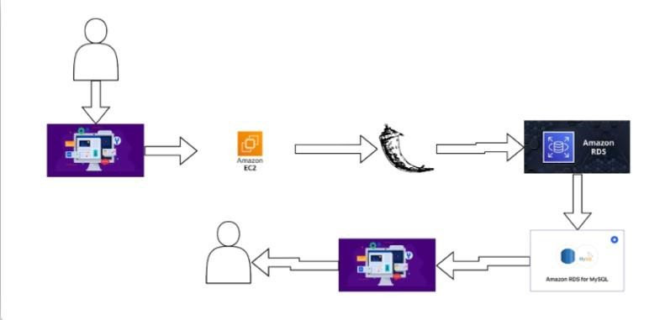

Project Proposal (Proposed Solution):

Blood Bridge is a cloud-native application that:
- Uses AWS to host a reliable, scalable infrastructure.
- Offers REST APIs for donor registration, inventory updates, and request management.
- Provides real-time access to blood product availability.
- Implements secure login and role-based access for donors, staff, and hospitals.
Features:
- Real-time Inventory Dashboard
- Donor Management System
- Request Fulfillment Workflow
- Role-Based Access (Donor, Hospital, Admin)
- Audit Logs and Monitoring
- Secure Data Handling
Benefits:
- Faster blood availability
- Reduced wastage
- Improved emergency response
- Seamless coordination between stakeholders

Initial Project Planning:

Product Backlog, Sprint Schedule, and Estimation (4 Marks)
Sprint | Functional  Requirement  (Epic) | User  Story  Number | User Story /  Task | Story  Points | Priority | Sprint  Start  Date | Sprint  End Date  (Planned)
Sprint-  1 | User  Onboarding &  Role Setup | USN-1 | As a user  (donor/hospital), I can register and choose my role. | 3 | High | 13  May  2025 | 15 May  2025
Sprint-  1 | Authentication  Integration | USN-2 | As a user, I can securely log in using AWS Cognito. | 3 | High | 16  May  2025 | 17 May  2025
Sprint-  1 | Blood  Inventory  Input | USN-3 | As a blood bank staff, I can enter blood stock details into the system. | 3 | High | 18  May  2025 | 19 May  2025
Sprint-  2 | Blood Request  Workflow | USN-4 | As a hospital, I can request a specific blood type and see realtime availability. | 4 | High | 20  May  2025 | 23 May  2025
Sprint-  2 | Notification  System | USN-5 | As a donor, I can receive notifications when blood is needed in my area. | 3 | Medium | 24  May  2025 | 25 May  2025
Sprint-  3 | Dashboard for  Admin | USN-6 | As an admin, I can view all blood stocks, requests, and user activity. | 5 | Medium | 26  May  2025 | 30 May  2025
Sprint-  3 | Audit &  Logging  (CloudWatch) | USN-7 | As a  developer/admin, I can track all operations and events using  CloudWatch. | 2 | Medium | 31  May  2025 | 01 June  2025
Sprint-  4 | UI/UX  Enhancements | USN-8 | As a user, I can interact with a clean, responsive | 3 | Low | 02  June  2025 | 03 June  2025
 |  |  | interface.
Sprint-  4 | Deployment  Automation | USN-9 | As a DevOps  engineer, I can deploy updates via CI/CD pipelines. | 2 | Medium | 04  June  2025 | 05 June  2025
Sprint-  4 | Final  Integration  Testing | USN-10 | As a QA, I can run end-to-end tests to validate all workflows. | 3 | High | 06  June  2025 | 07 June  2025
 | Reserve Buffer  / Contingency  Time | — | For unexpected changes, fixes, or rollout support. | — | — | 08  June  2025 | 13 June  2025

AWS Services Utilized

1. Amazon S3 (Simple Storage Service)
- Description: Amazon S3 is used for secure and scalable storage of blood inventory data, reports, and associated documents (e.g., donor certifications, audit logs, hospital requests).
- Use Case in BloodBridge: Stores uploaded forms, blood test reports, systemgenerated logs, and images. Provides versioning and durability.

2. Amazon EC2 (Elastic Compute Cloud)
- Description: EC2 provides resizable compute capacity in the cloud, acting as virtual servers to host backend logic, APIs, and process-intensive operations.
- Use Case in BloodBridge: Hosts the REST API backend, handles hospital-donor matching logic, processes data queries, and connects securely to databases.

3. Amazon DynamoDB
- Description: A fully managed NoSQL database that delivers high-performance read/write throughput with low latency at scale.
- Use Case in BloodBridge: Used for real-time blood inventory tracking, donation history, and blood type availability. Optimized for speed and high-availability scenarios.

4. Amazon RDS (Relational Database Service)
- Description: A managed relational database service that supports MySQL, PostgreSQL, and more. It provides security, scalability, and backup management.
- Use Case in BloodBridge: Stores structured data like user credentials, donor-recipient profiles, blood request logs, and access control records.

Application Deployment Steps

Deploying the BLOODBRIDGE application involves a systematic series of steps to ensure reliable performance, security, and scalability on AWS infrastructure. Below is a breakdown of the key deployment stages:

Step 1: Local Development – Code Compilation & Testing
- The BLOODBRIDGE application is first developed and tested in a local development environment using appropriate tools (e.g., Node.js, React, Python, etc.).
- Developers validate functionality through unit tests, local builds, and static code analysis.
- Configuration files such as environment variables, .env files, and resource definitions are prepared for deployment.

Step 2: Automated Deployment to AWS
- Once the codebase is validated locally, deployment is initiated using automation tools like AWS CLI, CodeDeploy, or Terraform scripts.
- Application files, including frontend builds, backend APIs, and configuration templates, are pushed to corresponding AWS services such as EC2, Lambda, or S3.

Step 3: Configuration of AWS Services
• AWS services are configured for optimal performance and security:
- EC2 instances are provisioned for backend API hosting. o Amazon RDS and DynamoDB are configured with correct schemas and roles.
- IAM roles, security groups, VPC settings, and auto-scaling rules are defined.

Step 4: Staging Environment Testing
- A staging instance of the application is deployed to simulate the production environment.
- Functional testing, integration testing, and performance monitoring are conducted to verify stability.
- Load testing may be performed to assess the system’s behavior under real-world conditions.

Step 5: Production Release
- Upon successful staging validation, the BLOODBRIDGE application is deployed to the production environment.
- DNS routing, HTTPS configurations, and access controls are finalized.
- The application becomes accessible to users via the live URL or hosted endpoint.

1. Results
6.1 Output Screenshots

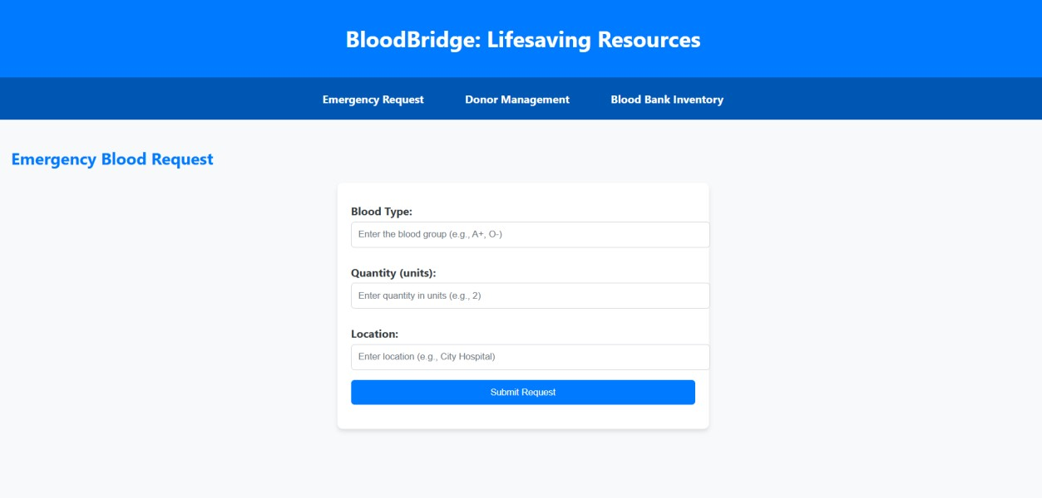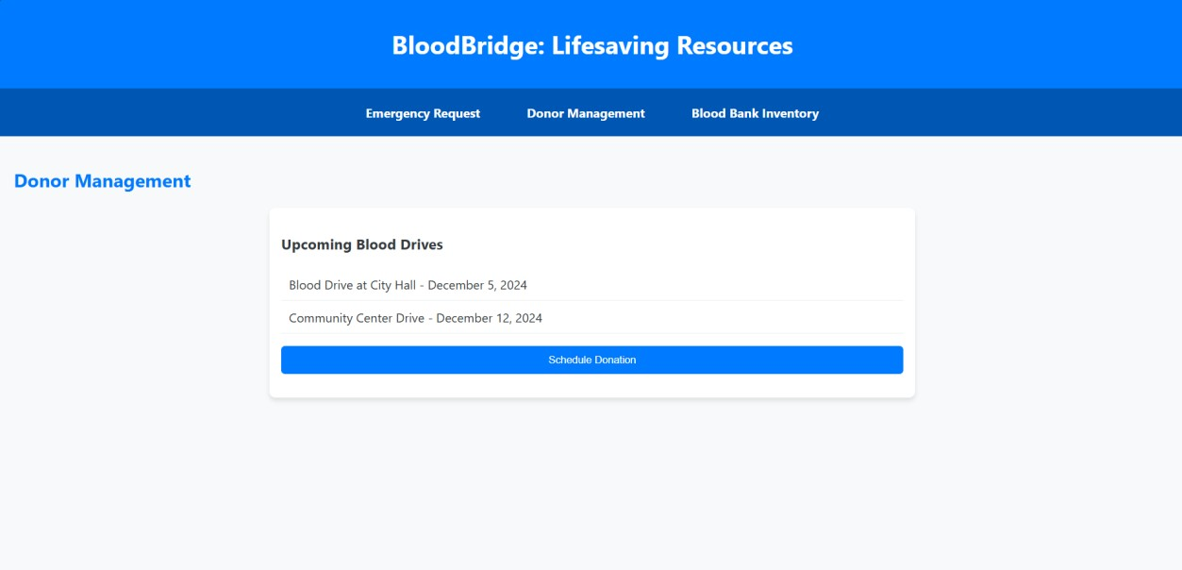
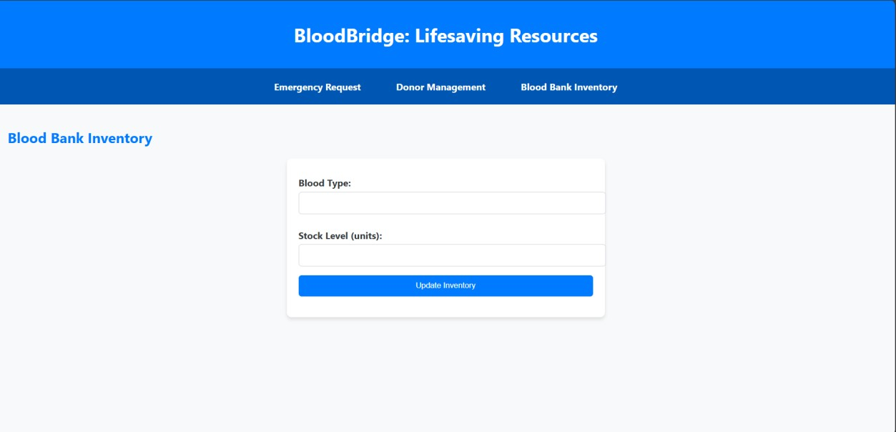

Advantages &Disadvantages:

Advantages:

- Real-time Inventory Visibility
BloodBridge provides hospitals and administrators with real-time visibility into blood stock levels, types, and expiration dates, enabling quicker decision-making and reducing delays in emergencies.
- Centralized Data Management
The platform unifies disparate systems across hospitals, donors, and blood banks into a single cloud-native infrastructure, eliminating redundancy and improving coordination.
- Scalability and Reliability with AWS
Leveraging AWS services such as EC2, Lambda, RDS, DynamoDB, and S3 ensures high availability, auto-scaling, disaster recovery, and compliance with healthcare standards.
- Enhanced Emergency Response
Through real-time request fulfillment and smart routing, hospitals can respond faster to critical needs, potentially saving lives during trauma and surgery cases.
- Role-Based Security and Access Control
With Amazon Cognito and IAM policies, the platform offers secure authentication and authorization, protecting sensitive health and donor data.
- Improved Donor Engagement
Donors can register, track their contributions, and receive notifications via the web/mobile interface—fostering continuous involvement and loyalty.
- Reduction in Blood Wastage
By enabling hospitals to forecast demand and ensuring that blood units are used before expiration, the system contributes to a significant reduction in wastage.
- Modular and Extendable Design
Future features such as AI-based prediction, chatbot integration, and mobile app extensions can be added seamlessly.

Disadvantages:
- Dependence on Internet and Cloud Services
Being a cloud-hosted solution, the system requires reliable internet connectivity. Disruptions in connectivity could affect access during critical moments.
- Initial Setup & Integration Effort
Hospitals and blood banks may need technical support during onboarding and system integration with existing infrastructure.
- Learning Curve for Staff
Non-technical staff may face a learning curve while transitioning from manual workflows to a digital platform, requiring training and change management.
- Operational Costs on AWS
While AWS offers scalability and reliability, its usage beyond free-tier limits incurs recurring costs depending on compute time, storage, and traffic.
- Data Privacy and Compliance Risks
Despite built-in security, storing health-related data on the cloud always demands rigorous compliance with laws like HIPAA or local data protection acts.
- Limited Offline Functionality
Features are heavily reliant on live cloud interactions, and the system may not function optimally in regions with low or unstable internet coverage.

Conclusion:

Blood Bridge represents a transformative step forward in the realm of healthcare technology, specifically addressing the inefficiencies and risks prevalent in traditional blood bank management systems. By leveraging a robust, scalable, and secure cloud infrastructure powered by AWS, the platform not only digitizes blood inventory processes but also facilitates real-time coordination among critical stakeholders—donors, hospitals, and administrators.
The integration of modern cloud-native technologies such as Amazon EC2, Lambda, RDS, DynamoDB, S3, and Cognito ensures that Blood Bridge is equipped to deliver high availability, secure access, and data-driven decision-making in mission-critical scenarios. Through features like real-time dashboards, automated request management, and audit-ready monitoring, the platform significantly reduces delays, enhances donor engagement, and improves emergency response efficiency.
Blood Bridge’s modular and extensible architecture lays the groundwork for future innovation, including AI-driven demand forecasting, mobile accessibility, and intelligent conversational interfaces. These advancements will enable the system to evolve continuously with healthcare needs and technological progress.
In conclusion, Blood Bridge is not just a solution to the existing operational challenges in blood distribution—it is a proactive digital infrastructure designed to save lives. By streamlining coordination and enhancing responsiveness, Blood Bridge sets a new benchmark for modern blood bank systems in both public and private healthcare sectors.

Future Scope
The BloodBridge project is designed with scalability and long-term impact in mind. As the healthcare landscape evolves and digital infrastructure becomes more central to public health, BloodBridge can expand in the following ways:
- AI-Based Demand Prediction:
  - Integrate machine learning algorithms to forecast blood demand based on historical trends, regional patterns, seasonal diseases, accident rates, and public events.
  - Prevent shortages or oversupply by proactively managing inventory levels.
- Mobile Application for Android & iOS:
  - Provide real-time updates for donors and hospitals. o Enable instant notifications for urgent requests or donation opportunities.
  - Integrate Google Maps for nearby donation camps or blood bank locations.
- Integration with Hospital Information Systems (HIS):
  - Automatically sync patient transfusion needs with BloodBridge.
  - Enhance workflow automation and reduce manual entry errors.
- Blockchain for Donor Identity & Donation History:
  - Use decentralized ledgers to securely store donor profiles, donation frequency, and medical history.
  - Ensure data integrity and traceability across institutions.
- Real-Time Logistics and Delivery Integration:
  - Partner with emergency services and logistics providers to track blood unit transportation in real-time using IoT-enabled temperature sensors and GPS.
- Voice and Chatbot Integration:
  - Implement AI-powered assistants for voice queries and automated responses.
  - Guide donors through eligibility checks, FAQs, and registration.
- Multilingual Support:
  - Localize the application to regional languages for better accessibility and adoption across diverse populations.
- Government Health Platform Integration:
  - Collaborate with national blood services and health portals to form a unified, country-wide donation and request network.
- CSR & Volunteer Management:
  - Allow NGOs, colleges, and companies to organize donation drives with scheduling, attendance tracking, and impact metrics.
- Analytics Dashboard for Administrators:
  - Provide insights into donor demographics, regional demand trends, and blood utilization to support data-driven policymaking.

Appendix

Source Code: - [ bloodbridge: optimizing lifesaving resources using rds,ec2 ]

Demonstration Video Link: - [ bloodbridge: optimizin33g lifesaving resources using rds,ec2 ]

